# All In One Metadata – Plugin – Documentation

## Description:

This is a plugin for the Wordpress CMS that can be used to add metadata on a website, the types of metadata supported by the plugin are from Schema.org, Dublin Core and Coins Metadata. The plugin supports integration with the Pressbooks plugin that enables the user to add Books on a website. This plugin works on both multisite installation and singe site installation of Wordpress. When the plugin is operating on multisite it has extra functionality which is described later in this documentation.

## Helpful Links:

* [All In One Metadata Repo](https://github.com/Books4Languages/pressbooks-metadata)
* [Wordpress.org](https://wordpress.org/)
* [Pressbooks](https://pressbooks.com/pressbooks-open-source-plugin/)
* <https://schema.org/>

## Installation

Installing the plugin is simple as downloading the files from Github and uploading the correct file in your Wordpress installation, link is provided above. Once downloaded extract the .zip file and navigate inside the folder that was extracted. Inside the folder you will see another folder named all-in-one-metadata, this is the plugin folder. You can upload this file using FTP to your Wordpress installation/wp-content/plugins or simply zip the all-in-one-metadata folder and upload it in your Wordpress installation using the plugins tab

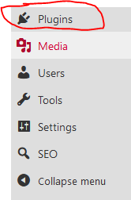

https://yourwebsite.com/ wp-admin/plugins.php by clicking on the Add New button.

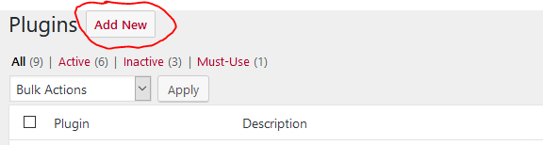

Once the plugin is uploaded activate it.

The same installation process is applied when installing on multisite.

## Required Plugins

For the plugin to fully function there is another crucial plugin that needs to be installed. Note that if you have Pressbooks installed you can skip this section of the documentation and jump to Using the plugin section.

Although if you are not using Pressbooks you have to install the required plugin named Custom Metadata Manager. All In One Metadata plugin will let you know with an error that the additional plugin is required and it will provide you with a link so you can download and install it.



By clicking the link in the error box you will be provided with the required plugin, upload the plugin to your Wordpress installation using one of the two ways described above when we were installing All In One Metadata, activate the plugin and the error will go away. Now we can start using our newly installed plugin.

## Using the Plugin

### Inner Wordpress Functionality relating to the plugin:

Before we dive into how the plugin works firstly we have to understand some key concepts about Wordpress and how it displays pages, posts etc. Any page or post or even a product that comes from another plugin in Wordpress is called a ‘post-type’. Wordpress has functionality that allows us to add new pages and new posts in our website by using the Wordpress interface. Adding a new page in Wordpress is like adding a new post of type page. Now every post type has different fields that take data and make up the final page that displays. For example when adding a new post to our blog we use fields like Title, Category, Featured Image, etc. These fields are called post-meta.

All In One Metadata detects all post-types that exist on the Wordpress installation; by doing this the plugin allows you to choose a post-type you want to add metadata and allows you to add metadata in the form of fields or ‘post-meta’. Then you can add information in these fields and create metadata for your page, post, product etc.

Note that if you have Pressbooks installed the default post-types will not show as Pressbooks plugin deactivates them from the interface. These post-types are Page, Post and Attachment.

Continue reading for a detailed description.

### Using the plugin on a single site installation (Adding metadata to a Post):

After you have installed the plugin along with its dependencies and you activated it you should be able to see a new setting under settings menu named ‘All In One Metadata Settings’. By clicking that you will be redirected to the options page for the plugin.

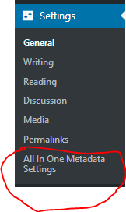

This is the Location Of Metadata section, remember when we talked about the Wordpress ‘post-types’ and that the plugin can detect all of them, well here is where you the user can choose where you want to add metadata that comes from Schema.org. This metabox is composed of two tabs Post Level and Site Level. Post level displays all post types, from there you can check the box for the one you want to enable metadata on and click Save Changes. The second tab has only one option inside and this option enables metadata on the homepage of the site like www.example.com.

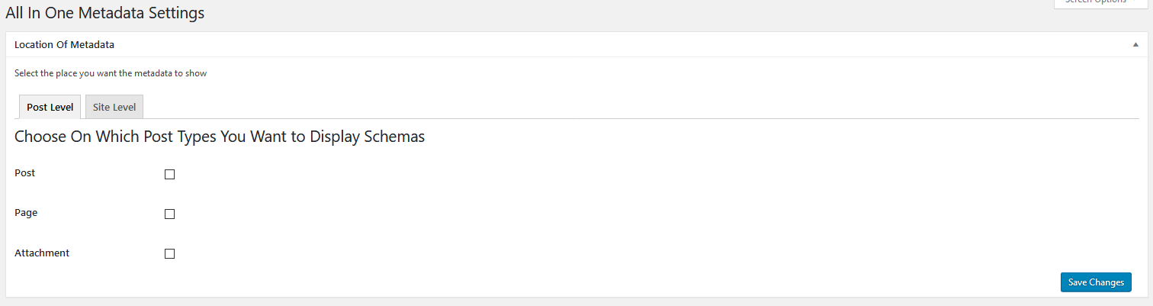

The second metabox in the settings page displays all the active locations that schema metadata will go in, if did not enable any post-type from the above metabox you will see this

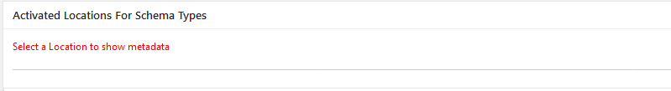

Let’s say you have chosen to add Schema.org metadata on some of your blog posts, this means you have to activate the Post checkbox in the ‘Location Of Metadata’ metabox and then click Save Changes.

After saving, the metabox named ‘Activated Locations For Schema Types’ will display the Post ‘post-type’ as a tab and will be selected by default as it’s the only active ‘post-type’.  
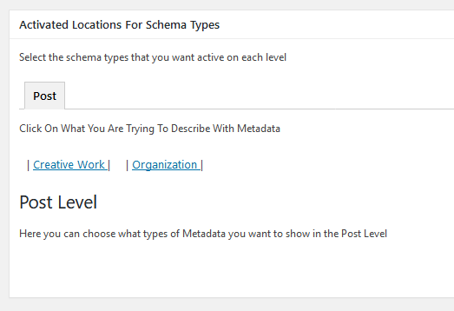

Now from here you can click on one of the links that better describes what you want to use metadata for, if for example your post is talking about a clip, click on the ‘Creative Work’ link and all the schema types that have to do with Creative Works will show up. For a list of types and properties that describe metadata please visit [Schema.org](https://schema.org/). Continuing with the example after you selected the appropriate link the metabox will display all Creative Work related types. See the picture below.

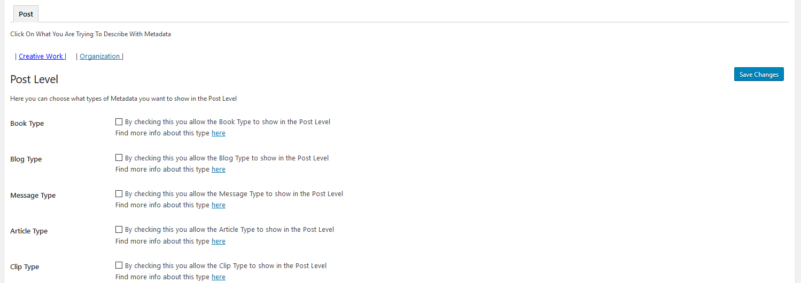

If your post will describe a clip please select the ‘Clip Type’ and click save Changes. By doing this you have activated the Clip Type metadata for posts.

After activating the type or types you want for the certain ‘post-type’ the page will refresh and you will see this under all activated types.



By clicking the ‘Edit Type Properties’ you can select witch data you want to describe for the clip, let’s see what this link shows in order for you to understand.

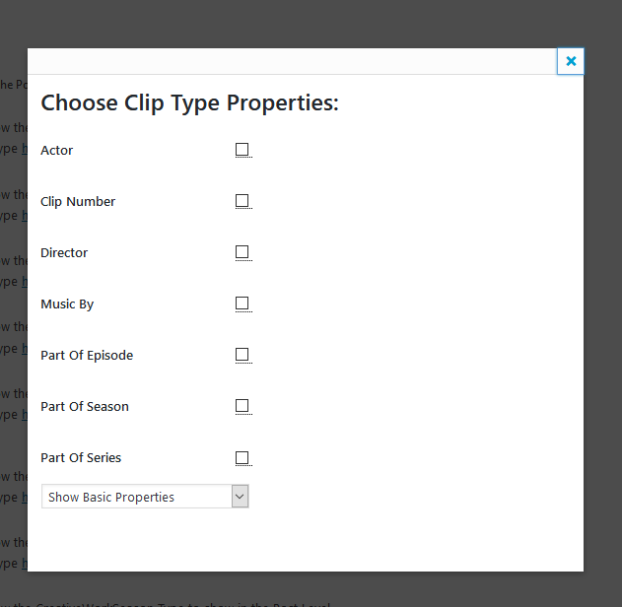

This panel shows up and shows what data to describe, let’s say you want to add metadata for the actor and the music of the clip. Simply to do this you have to click on the checkbox for the Actor and the Music By. When clicking on the metabox you can see a description for each property so you don’t have to go to the schema website all the times, once you select or deselect an item from the list the data is saving automatically, some properties will be enabled by default for some types, it means that these properties are mandatory from the schema.org and it’s always good to fill them when creating the post.

The drop down menu on the bottom shows alternative properties for the type that you selected.

Finally after enabling the ‘post-type’ and the data we want to describe in the post type, we can head to our new post and start adding the data for the metadata to work.

As you guessed the new fields now show up in every post we edit or create, see below. NOTE that if you activate a type and you don’t select any properties the metabox will not show in your posts because you simply did not choose anything to describe, if the type though has required properties by activating it the required properties will show in the metabox.

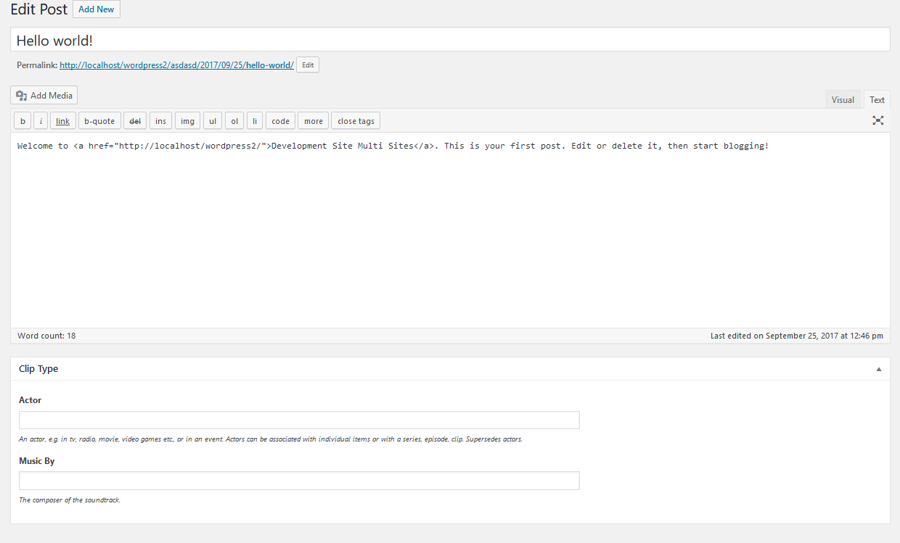

Now simply add some info in the two fields to describe the selected properties and click Save Changes. Excellent your post now has metadata for a clip author and music that google can understand.

A small briefing on what we did until now:

1. Installed the plugin
2. Installed dependencies
3. Activated metadata in the Post type from the settings
4. Selected that we want to describe a creative work
5. Activated a creative work type named Clip
6. Selected properties from the Clip to describe
7. Created a new post and added the data in the fields for the metadata
8. Saved the post

### Using the plugin on a single site installation (Adding metadata on the Homepage):

So far we have discussed how to use the plugin to add metadata to any kind of post-type like Post, Page and Attachment. Following up in this section we will see how to add metadata on the homepage of our website. Please make sure to read the section above because this section depends strongly on the information above.

To achieve what we want to do we simply have to navigate back to our plugin settings page and enable the checkbox that is under the Site Level tab in the ‘Location Of Metadata’ metabox. After checking the checkbox click Save Changes.

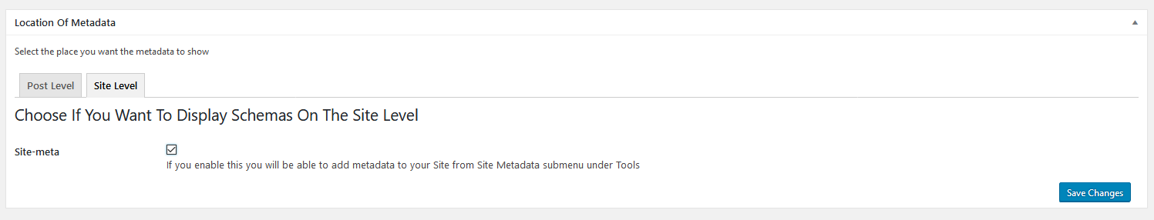

As expected now we can see another tab in the ‘Activated Locations For Schema Types’ metabox named Site Meta.

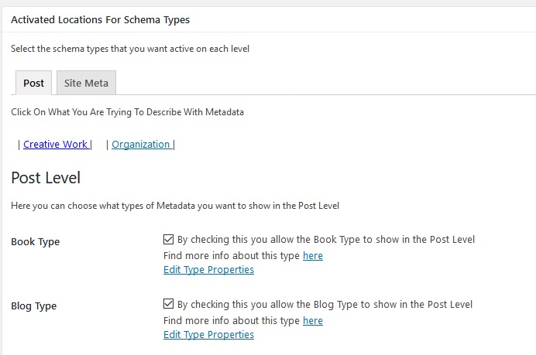

Now simply click on the new tab in the Locations metabox named Site Meta and choose a type that describes your website. After you choose the desired schema-metadata type click Save Changes. For this example I choose to select a type that comes from the Organisation link above since we are describing a whole website. The type I choose is named Local Business. Now as we did before we have to select again things we want to describe about the Local Business, simply click on the ‘Edit Type Properties’ link.

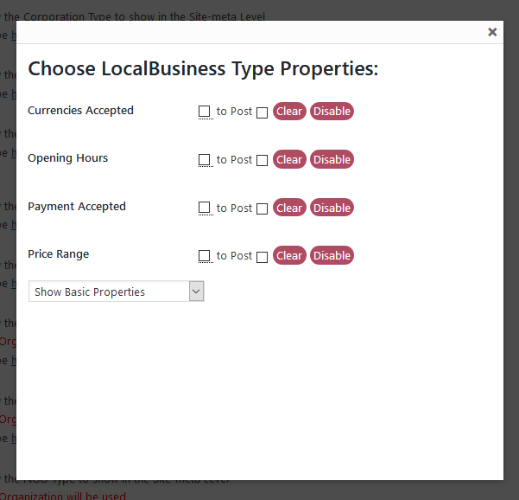

Don’t worry about the extra functionality here I will explain later in this section how it works.

Here again you can choose to select some properties that you want to describe, for my example I choose the ‘Opening Hours’ property, once you selected the properties you want, just navigate in the Tools tab and select Site Metadata.

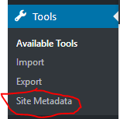

Here is where we edit the fields that will enable the metadata in our homepage.

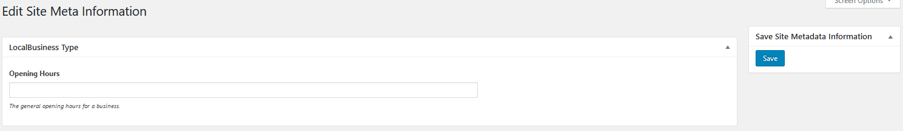

Just by filling in the ‘Opening Hours’ field and clicking Save Changes Google can understand the opening hours of our business.

Extra Site-Meta functionality:

As you saw before, the panel of editing type properties on the Site-Meta tab under the ‘Activated Locations For Schema Types’ metabox had some extra functionality.

The idea here is that you can clone data from your homepage metadata to a ‘post-type’ of type Post. If this is confusing don’t worry we will break it down with an example. In our previous example we created metadata for our homepage, the schema type selected was ‘Local Business’ and the activated property was ‘Opening Hours’. Now let’s say you want to automatically enable this metadata of Opening Hours along with the value you gave it for the homepage to exist on all your Posts. This is as simple as checking the ‘to Post’ checkbox. C:\Users\chris\Downloads\Documentation\clonig_to_post.PNGHere I marked the checkboxes and the buttons with letters so we can break down the functionallity of each one.

Checkbox a:

This checkbox enables the selected property on the selected level, in this example we enabled the property Opening hours from the type Local Business on the Site-Meta level witch is our homepage metadata.

Checkbox b:

This checkbox once is checked (buttons c and d dissapear) we will describe their functionality later.

Anyhow checking the checkbox b will automatically enable the post level. The post level is our posts. If the post level is completely disabled from the metabox ‘Location Of Metadata’, this option will enable it. Moving on, the ‘Local Business’ type will be enabled in the post level and finally the property ‘Opening Hours’ will be anabled. After everything is enabled the property Opening Hours value that comes from our homepage metadata (Site-Meta) will be cloned/overwritten to all of our posts. For the example I used the value 10am – 20pm when creating this property on the homepage metadata.  
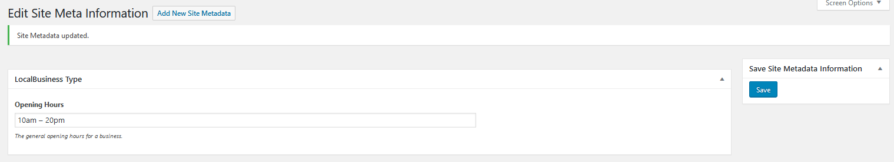

Now after checking the checkbox b the above activation and cloning actions will take place. After navigating to any post now you will see this:

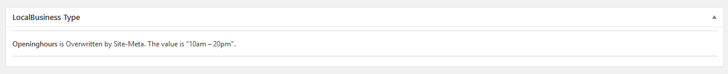

Now all your posts have the ‘Opening Hours’ property enabled and their data comes from Site-Meta witch is your home page metadata. As you can understand this functionality can save you a lot of time by not having to go in every post and add the same data over and over again.

Button c and d:

As you noticed in the above example, by checking the checkbox b buttons c and d were disabled. By unchecking the checkbox b these buttons will reappear, read further to understand why. In our previous example we cloned the ‘Opening Hours’ property to all posts. If we decide to undo this action and stop overwriting the property we have to uncheck the checkbox b. Then the button c and d will appear and the overwritten property will show like this in the posts.

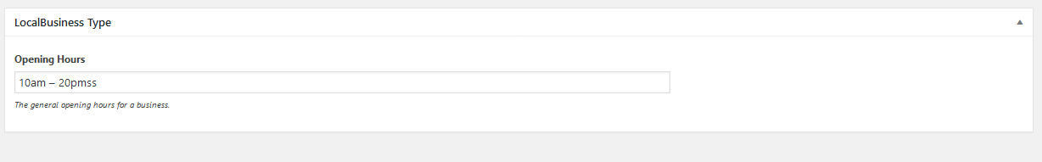

So as you understand while a property is overwritten or cloned it cannot be changed, but once we decide to release it or stop overwriting it, all the data stays on the posts, like if we had manually typed them. Simply now you can change the data on every post or you can use the button c and d.

By using the c button you tell Wordpress to clear all the fields of property ‘Open Hours’ on all posts. The result of this action is the above picture again but with the property field empty.

By using the d button you tell Wordpress to disable the property ‘Opening Hours’ from the post level. Note that this will just disable the property NOT the schema type or the active post level.

As you can see these last two buttons are for clearing or disabling a property after it has been cloned/overwritten, this saves time as you don’t have to navigate to the post level in order to disable the property.

### Using the plugin on a single site installation (Adding Coins and Dublin on the Homepage):

As said in the description of the plugin we don’t just support the schema.org metadata but also the Coins and Dublin metadata. Using these two vocabularies in our plugin is quite simple, just navigate in the settings page and scroll down until you see the ‘Specific Metadata’ metabox.

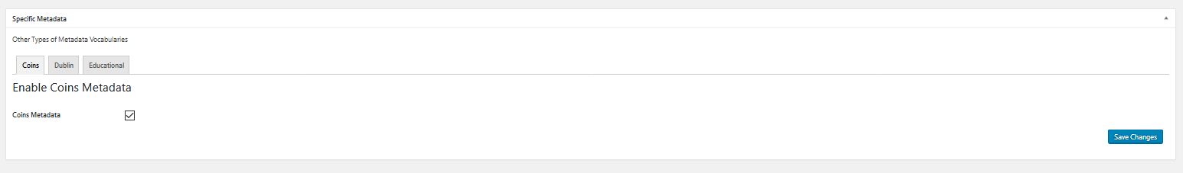

From there just select the Coins tab check the checkbox and click Save Changes, this will enable the Coins metadata on your homepage, similarly enable the Dublin metadata by going to its tab checking the checkbox and clicking Save Changes. As you remember from our previous examples all metadata related to our homepage can be edited under the Tools tab by selecting Site Metadata. After activating the vocabularies and navigating to the Site Metadata you should see two metaboxes with predefined properties for each metadata vocabulary. Fill in the ones you like and click save. Any property that is left empty will not display any data on the mark-up of the site.

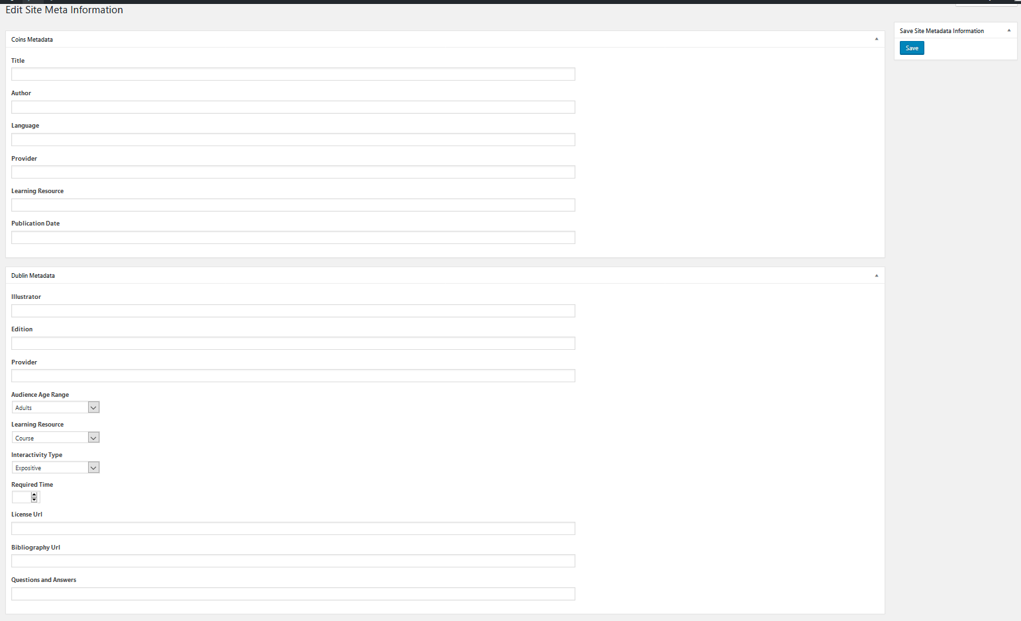

### Using the plugin on a single site installation (Enabling Educational Metadata on the Homepage/Post):

General Information

Finally we packed our plugin with something extra that has to do with education. The said Educational Metadata was created for anyone that specifically wants to add metadata on a website that has to do with education. Technically this metadata is not something new, it’s just some important pieces of information that we decided are important and we choose them to be packed for educational purposes. Under the hood our educational metadata uses some schema.org properties in order to operate. By using this you cover the most important educational metadata and you don’t need to search for them through schema.org and manually enable them from our interface of types and properties.

Enabling on the Homepage:

As previously explained in the Coins and Dublin vocabularies section, this Educational Metadata function can be enabled for the homepage by going in the ‘Specific Metadata’ metabox in the bottom of the settings page and selecting the Educational tab. There you can check the ‘Educational Metadata Site Level’ checkbox and click Save Changes.

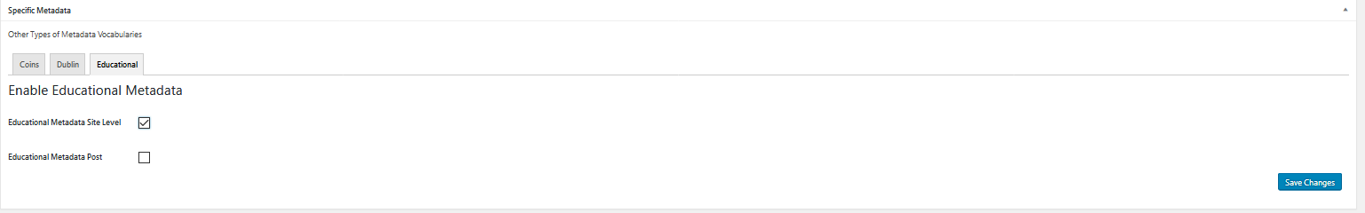

As you remember from our previous examples all metadata related to our homepage can be edited under the Tools tab by selecting Site Metadata. After activating the Educational Metadata and navigating to the Site Metadata you should see a metabox related to the enabled metadata.

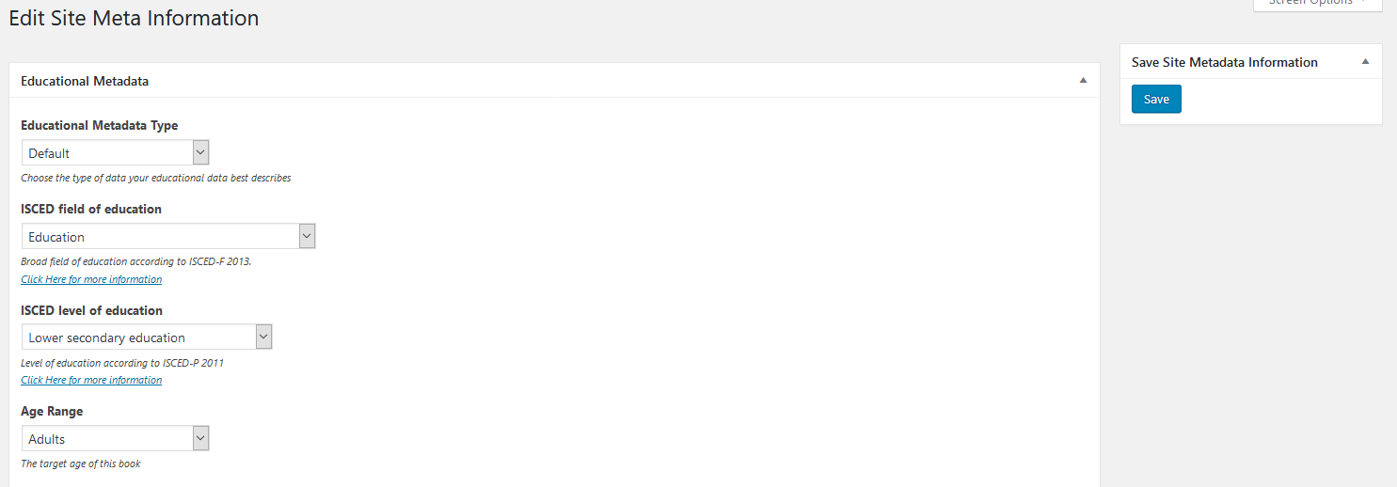

Here you can fill in all information and click Save. After this action Google will read all passed in data from your homepage mark-up. The only field I have to note here is the one named ‘Educational Metadata Type’. By default this field wraps all data entered in the educational metabox and displays them to Google as if our educational data on our homepage describes a website (here we are referring to the [Website](http://schema.org/WebSite) type of schema.org). You are allowed to change this field by selecting it, anything you choose will just better describe the educational information you are presenting to the Google crawler. Click on the dropdown menu to see what other options you have.

Enabling on the Post type:

From the ‘Specific Metadata’ metabox in the bottom of the settings page select the Educational tab. There you can check the ‘Educational Metadata Post’ checkbox and click Save Changes.

After enabling the educational metadata and navigating to any post you will see this metabox.

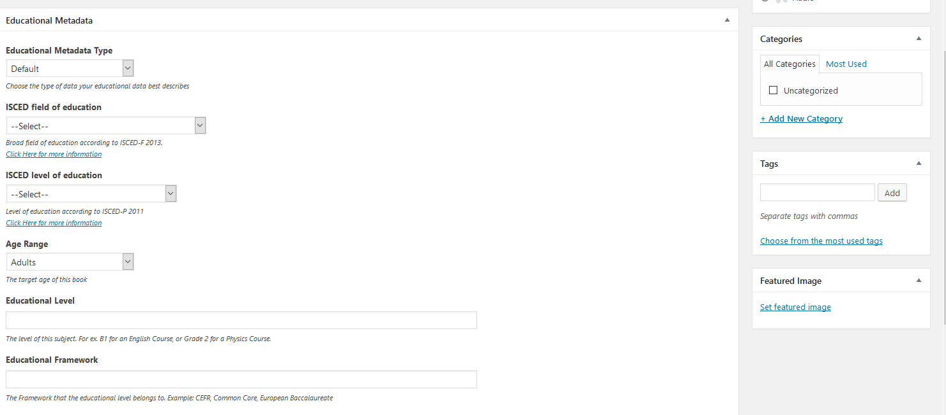

Here you can fill in all information and click Save. After this action Google will read all passed in data from each post’s mark-up. The only field I have to note here is the one named ‘Educational Metadata Type’. By default this field wraps all data entered in the educational metabox and displays them to Google as if our educational data on our post describes a webpage (here we are referring to the [Webpage](http://schema.org/WebPage) type of schema.org). You are allowed to change this field by selecting it, anything you choose will just better describe the educational information you are presenting to the Google crawler. Click on the dropdown menu to see what other options you have.

### Using the plugin on a multisite installation (without Pressbooks):

As said the plugin is also functioning in a multisite Wordpress installation. NOTE that you need to read all the above sections on how to use the plugin in a single site installation in order to understand the proceeding documentation. The installation and required plugins sections are also mandatory.

What you can do on every site or root site in your multisite installation is exactly the same as when we were using the plugin in a single site installation. All the functionality of the plugin is available on all sites of your installation and every site has its own metadata and settings. The differences are just 2. One of the differences is that there is a new empty tab under the ‘Location Of Metadata’ metabox on the settings page of the plugin in every site. This tab is named ‘Multisite Level’ and currently has no functionality. This will have functionality in a later release of this plugin. The second IMPORTAND change when using the plugin on a multisite installation is a new settings page for the network admin ONLY.

To see the settings page simply navigate to the network admin page ‘www.example.com/wp-admin/network/’. From here you can also activate the plugin from the Plugins tab using network activation, this will make the plugin accessible to all admins using sub-sites in your installation.

The new settings page can be found under the Settings tab, the settings page name is ‘All In One Metadata Network Settings’.

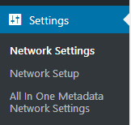

This is the network settings page for our plugin:

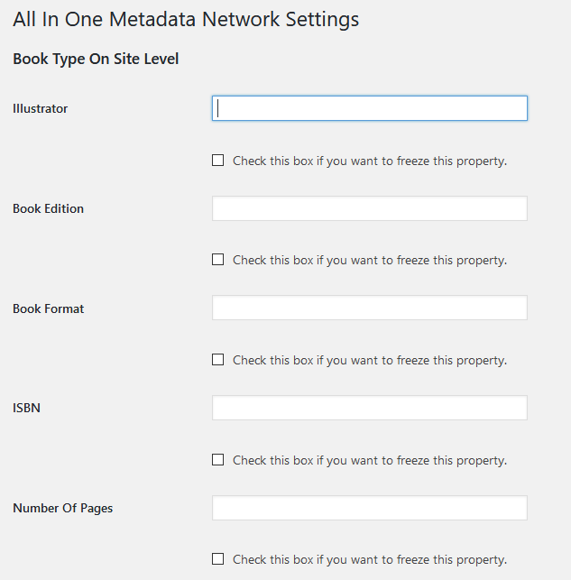This page is very long as it’s still under development, the main functionality it contains will be covered here. Changes will occur in a later release because the navigation of this page is not efficient as it has a long scrolling and as not all of the schema.org properties are displayed.

Let me explain a scenario of when this functionality is needed so you can easily understand. Let’s say you are the owner of a very popular website that acts as a catalogue for books (ROOT SITE). And this catalogue leads users into many sub-sites that each site is a different book. Your book-websites are currently 100.

What if you wanted to add metadata to all the books homepage’s without having to go through all the book-websites.

Well if you found yourself in such a situation here is how you can do everything with some clicks  
In this example we assume that all the books of our multisite have the same book format. So we simply need to add this metadata information on all homepages of our books. To achieve this, navigate to the ‘Book Type On Site Level’ section in the plugin network settings. We are choosing the ‘Book Type’ from schema.org as we want to describe a book to Google. Then, type the data you want in the ‘Book Format’ input field. By doing this and clicking Save Changes here is what happens on all sub-sites. The parenthesis after each step explains where these settings can be found manually on each subsite. NOTE that whenever you click Save Changes the actions below are executed.

* Site-Meta Level is activated - (‘Location Of Metadata’ metabox in plugin settings)
* The Book Type is activated for the Site-Meta level (‘Active Locations For Schema Types’ metabox in plugin settings)
* The filed in property named ‘Book Format’ is activated for the Book Type Under the Site-Meta Level (‘Edit Type Properties’ link under the Book Type in plugins settings)
* The filled in property value distributes its self on the property field for each site.

Here is the result showed in the Toos/Site Metadata (homepage metadata) for one of my subsites after running the above example.

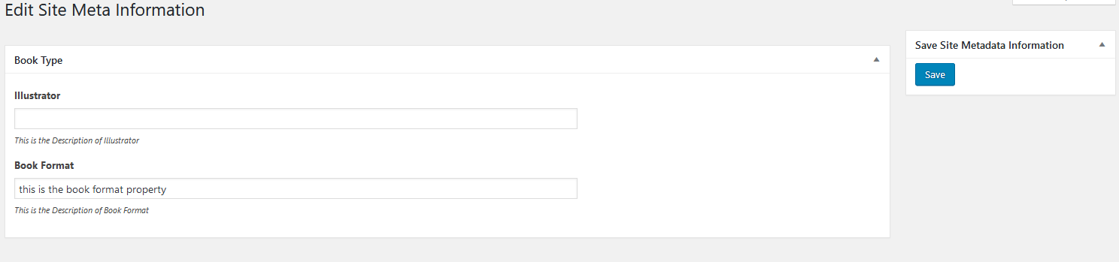

NOTE that this data now is just being distributed and enabled, but any sub-site admin can simply change the property value and save it. If you want to make this property ‘Book Format’ frozen and mandatory to all sites without anyone being able to modify it just use the checkbox below the property field before saving your network settings.

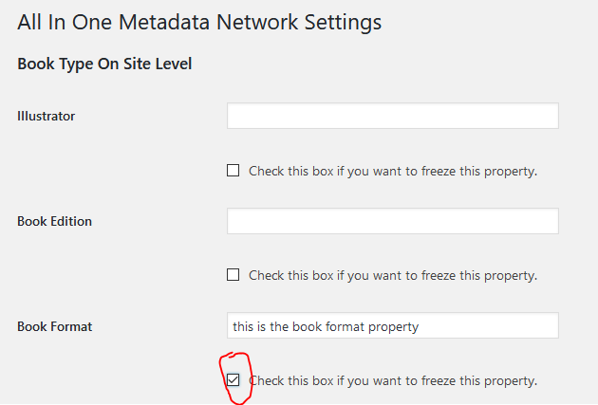

After doing this and clicking Save Changes the result will be that no one can go to a sub-site and disable or change the value of the property ‘Book Format’.

Here is the result showed in the Toos/Site Metadata (homepage metadata) for one of my subsites after running the above example.

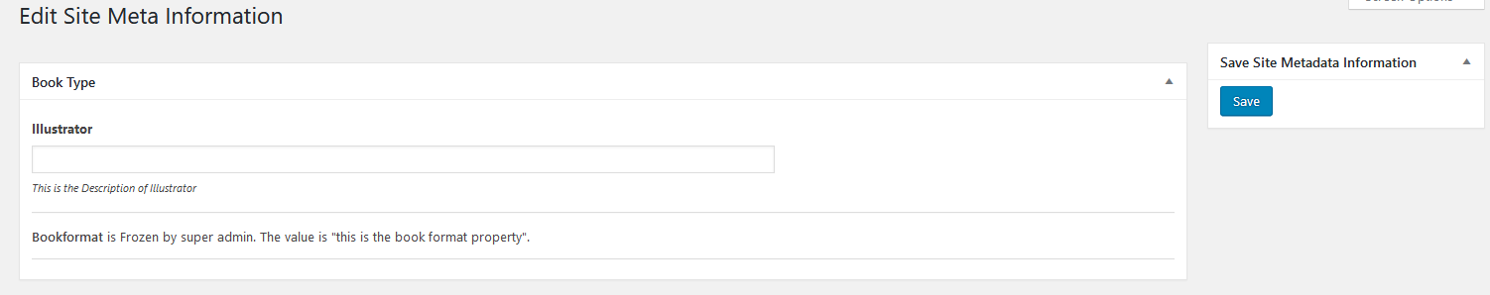

NOTE that in both examples we can see the ‘illustrator’ property that comes from the ‘Book Type’. This happens because the illustrator property is said to be a mandatory field for the Book Type. Well this is just an example though in reality the illustrator property is not needed, but if you see any property fields that you did not choose, try to fill them up for improved metadata.

### Using the plugin on a multisite installation (with Pressbooks):

As said the plugin is also functioning in a multisite Wordpress installation with Pressbooks installed. NOTE that you need to read all the above sections on how to use the plugin in a single site / multisite installation in order to understand the proceeding documentation. The installation section is also mandatory.

Well if you have clearly understood the above sections on installation and usage it would be a matter of seconds to understand how the plugin operates on an installation that Presbooks is also present. NOTE that with the Pressbooks plugin installed you do not need to install the required plugin Custom Metadata Manager.

What really changes when Pressbooks is running in parallel with All In One Metadata:

1. The levels you can enable metadata on, change to the Pressbooks ‘post-types’ and the default Wordpress ones are invisible.

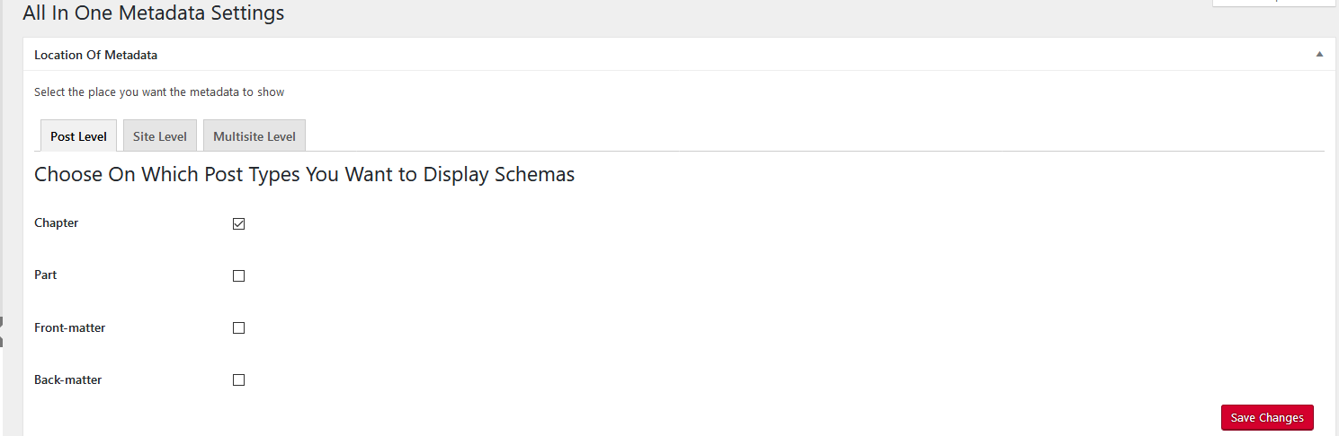

1. When you enable the Site-Meta checkbox from the Site Level tab in the ‘Location Of Metadata’ metabox to enable metadata on your homepage, the way to edit these metadata fields is not anymore under Tools/Site Metadata, they are now located in another tab that comes from Pressbooks. The tabs name is Book-Info. So whatever you enable for the Site Meta will appear there.

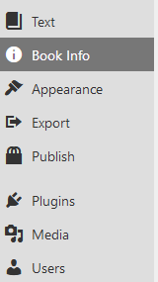

1. Now when you want to clone data from your Site Meta level to a post you don’t actually clone it to a post but to a chapter because Pressbooks is using chapters instead of Posts. So everything explained in previous sections that were talking about overwriting data to Post now happens with a chapter.

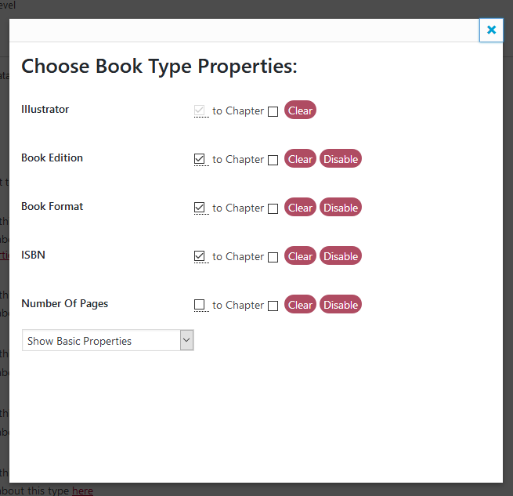

1. Enabling other vocabularies like Coins, Dublin and Educational for Site Level, again will show inside Book-Info tab! NOTE that whatever was related to Tools/Site Metadata now is under Book-Info along with other Pressbooks settings. Also for enabling the Educational Metadata on a post now has become chapter because as we said posts do not exist on a Pressbooks installation.

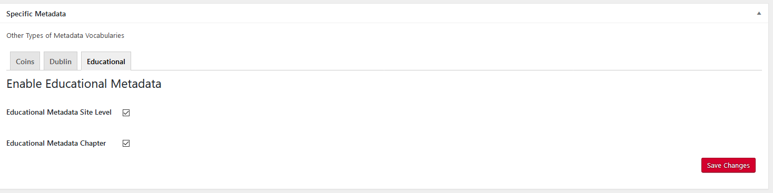

1. Educational Metadata for the Site Level now as we said appears on the Book-Info tab, the dropdown option ‘Educational Metadata Type’ now is removed as Pressbooks treats the homepage Educational Data as Book Type data automatically.

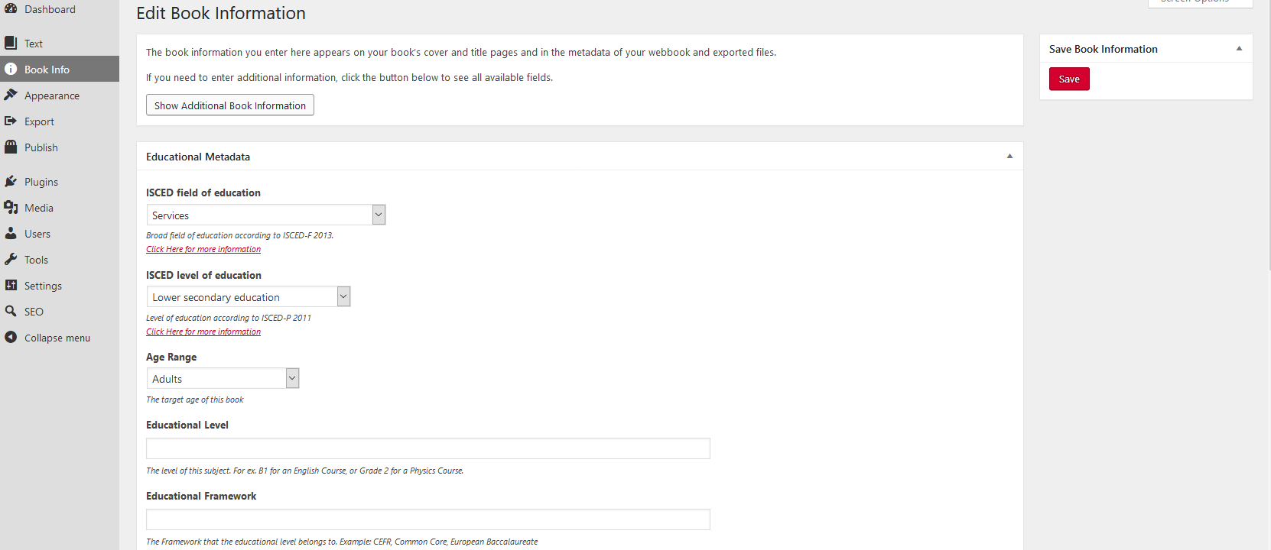

1. Finally a small note to avoid confusions. When distributing / freezing data from the network admin settings remember again that all fields now show in the Book-Info tab that is responsible for all the metadata that renders in the mark-up of each books homepage.